Calculate the number of employees corresponding to each skill from the table 'employee' which is

loaded in the Demo.

1. Create table in hive

create table if not exists emp_details

(

name string,

skill string,

exp int,

location string

)

row format delimited

fields terminated by ',';

1. Load data in emp_details table:

LOAD DATA LOCAL INPATH '/home/acadgild/nikidir/emp_details.txt'

OVERWRITE INTO TABLE emp_details;

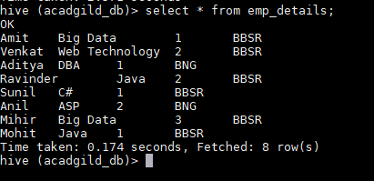

1. Query to calculate skills:

select skill, count(*) from emp_details group by skill;

